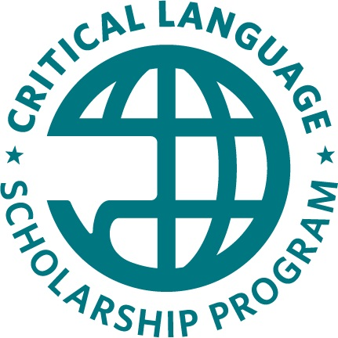

CLS Application Essays Worksheet
This document is intended as a resource for students to make notes and begin drafts of their essays for the 2021 Critical Language Scholarship Program. This worksheet is NOT a part of the CLS application, which is available online at https://clscholarship.org/apply
We recommend beginning your online application early, as the essays only make up one section of the longer application form.
Please note that word counts in this document and in other word processing systems may vary from the word limits provided in the online application form.
In addition to using this document to prepare drafts of your essays, we encourage you to consult the following resources:
- CLS selection criteria: https://clscholarship.org/applicants/selection
- CLS tips for strengthening your application (video): https://youtu.be/6yrYywRQuoo
- Find a CLS advisor on your campus: https://clscholarship.org/universities

Apply Online
Applications must be submitted online at https://clscholarship.org/apply no later than November 17, 2020 at 8:00pm EST.

Resilience (300 words)
Successful study abroad experiences often require traits such as flexibility, tolerance, openness, and adaptability. On the CLS Program, you will be exposed to new beliefs, values, attitudes, and opinions. For example, you might find that there are differences in concepts of privacy; socially acceptable behaviors; the role of the individual in society; and/or values and political viewpoints.
- Give an example of when you had to adapt to a new environment or situation.
- Based on that experience, what are your strategies for interacting with people who are different from you or situations that are unfamiliar?

Questions to Consider
- How have you dealt with challenges in your life? Do you have coping mechanisms, or hobbies or interests that can sustain you in times of stress?
- Can you demonstrate humility, sense of humor, and/or an ability to cope with ambiguity or miscommunication using an example from a past situation or experience?
- How will you cope with the unique stresses of living in another cultural setting?

Begin Your Draft
[Begin your draft here]

Preparation for the CLS Program (300 words)
The CLS Program is an intensive, group-based overseas learning experience. The program involves adapting to a new culture and environment, an intensive academic program, and mandatory cultural activities that may not always align with your interests. CLS involves building new relationships with people from the host country and functioning day-to-day in another language. CLS cohorts are often very diverse and maintaining positive group relations can be challenging. There may also be challenges specific to the location in which you study, and your own identity, background, and experiences.
- What aspects of the CLS Program do you expect will be the most challenging for you?
- What knowledge, skills, and experiences will you draw on to meet these challenges?

Questions to Consider
- How will you handle the intensive, immersive, highly structured learning environment of CLS?
- Can you demonstrate skills like perseverance and commitment?
- How will you make a positive contribution to the group dynamic?

Begin Your Draft
[Begin your draft here]

Citizen Diplomacy (300 words)
A key goal of the CLS Program is to increase the number and diversity of Americans who study and speak critical languages in order to develop mutual understanding between the people of the United States and the people of other countries. Languages offer an opportunity for communication and exchange, providing the foundation of a more peaceful world. CLS Program scholars bear responsibility for representing the United States as citizen diplomats in their host communities; they reflect a diversity of values, beliefs, and opinions that is fundamental to providing a balanced representation of the United States abroad (see the diversity statement of the Bureau of Educational and Cultural Affairs).
CLS Program scholars are expected to contribute to the goal of building mutual understanding by sharing what it means to be an American, learning about the host culture, and building meaningful relationships. After the program, alumni share their overseas experiences with others in the United States.
- Consider how your unique experience and perspective might contribute to your cohort.
- Make a case for how you will serve as an effective citizen diplomat abroad. How could you contribute to the mission of building mutual understanding between the people of your home community and the people of your host community?

Questions to Consider
- What distinguishes you from most other applicants?
- How will you interact with people from the host country as a representative of the United States abroad? How will you represent the United States abroad? What aspects of your character, identity, or personal story do you feel are uniquely American?
- Think about the different communities of which you are a member. How can this experience help you to contribute back to them?

Begin Your Draft
[Begin your draft here]

Commitment to Language Study (200 words)
The CLS Program seeks to support students who are committed to acquiring a high level of linguistic and cultural knowledge about the regions and countries in which they study.
- What interests you about your chosen target language and the people who speak it?
- How will you continue to study this language after the CLS Program?

Questions to Consider
- What resources are available to continue your language study?
- Will you be able to take courses on your campus or at the next institution you attend? If not, how can you be creative in your plan to continue your path to proficiency?

Begin Your Draft
[Begin your draft here]

Statement of Purpose
Please address the following questions in your statement of purpose:
- How will increased language and cultural knowledge help you achieve your future academic or professional goals?
- Why is participation in the CLS Program appropriate for you at this point in your academic or professional career?
- Why should the CLS Program invest in you? What is it that you bring to the program?

Points for Consideration
- Be as specific as possible in describing your academic and professional goals
- Describe how language and cultural skills will benefit these goals
- Be clear about the connection between your specific chosen target language and these goals
- Consider:
  - How did you become interested in your chosen field, language, culture, and/or region?
  - What you have done up to now to cultivate this interest?
  - Why is now the right time for you to participate in CLS?

Begin Your Draft
[Begin your draft here]

